Tim Tognazzini
tognazzini@hotmail.com
Abstract
A programming system used to quickly develop high quality consistent programs.
PROGRAM MASTER SYSTEM

Table of Contents
1 Introduction 4
1.1 Document Scope 5
1.2 Acronyms and Definitions 5
1.3 References 5
1.4 Supplemental Documents 6
2 Programing Standards Overview 7
2.1 RPG **Free Limitations 7
2.2 Basic Theories and Standards 7
2.3 Standard Rules 7
3.1 Capitalization 11
4 Program Naming Conventions 13
4.1 Object Type (Seventh character of name) 13
4.2 Program Sequences (Eighth character of the program name) 13
4.3 Special codes for 9th and 10th characters 13
4.4 Program Names Examples 13
4.5 Source File 14
4.6 File names 14
4.7 File Types 14
4.8 Other Object Names 15
5 Screen Design 15
5.1 Standard Screen Headers 15
5.2 Command Key Standards 16
5.3 Help Text Standards 17
5.4 SFL Function Standards 17
5.5 Screen Standards 17
5.6 Screen Standards SFL Screens 20
6 RPG Coding Standards 21
6.1 Control Options (Ctl-Opt) 21
6.2 Indenting 21
6.3 Loop Control 22
6.4 DRY Principals 22
7 CL coding Standards 23
8 Base function service program 23
9 Template Program Service Program 24
9.1 Fields 24
9.2 Procedures 24
11 Template System 27
11.1 Caveats 27
11.2 Building the Database Table 27
11.3 Library List Issues 33
11.4 Creating Template Programs 33
12 Prompting and Auto Fill Fields 42
12.1 Promptable User Entered Fields 42
12.1.1 User Defined Autoprompt Program Example 42
12.1.2 User Defined Prompt Program Example 43
12.2 Promptable Enumerated Values 44
13 Display File Preprocessor 45
15 LMI Types and Codes 47

Introduction
The intent of this document is to outline programing standards for a new style of programming. The goal is to increase programmer efficiency in both writing and maintaining code. As well as creating high quality consistent programs.
The Program Master system is a combination of coding standards, design standards, service programs and program templates designed to increase programmer efficiency in developing and maintaining code.
It enforces high quality code through several methods. The list below outlines some of the benefits of using this system.
Code Standardization - Standardizing the coding methods allow programmers to quickly pick up a program they have never worked on before. If all programmers use a consistent set of programming standards, then everyone will be comfortable working in the same environment. This reduces the maintenance overhead of the entire system.
Screen Standardization - Standardizing screen assists both the programmer and the end user. The developer is assisted by not having to think about how to lay out screens, all the hard design aspects are already determined. Screen standardization assists the end user by promoting many of the basics of HCI. The primary principles of HCI are predictability, synthesizability, familiarity, generalizability, and consistency. Using standard screens allows the user to learn one program and then be comfortable working in any program in the system.
Service Programs - Many common functions have procedures written for them in one of two service programs in the system. The first service program is a general tool library. It is called CBTFNCV1. It contains base functions used in many programs. The second service program is APLSRVV1. It has procedures geared directly to the program master templating system.
Template Programs - The system uses template programs to generate new programs. The template programs contain all the boiler plate code for the flow of the program. These speed development and provide a consistent environment for developers.
Programs written using these standards are intended to use the newest programming methods and techniques available at the time of writing. These standards and techniques are geared around creating an efficient workspace using new tools and methods that increase programming efficiency while writing, updating and maintaining code.
The new programming environment will be RDi or VS Code. This replaces the PDM/SEU combination that has been used up until this point. SEU has not been supported by IBM since V6R1. IBM came up with a more modern feature rich source code editor back in the late 1990’s. This editor was created to provide some of the benefits provided by IDE’s in other modern languages. Since then, nearly all programming languages have multiple IDE options for development. RDI and VS Code include productivity enhancing features like program outlines, text highlighting, task tags, advanced program navigation, integrated help, auto command completion and much more.

Document Scope
This document is intended to lay out the standards used to write programs. It is not a how-to document. How-to documents will be separate. The next section provides a list of supplemental documentation that should be used to understand how these standards will be implemented.

Acronyms and Definitions
HCI - Human Computer Interactions, a field of study used to assist with the interfacing between humans and computers. This website describes it: https://bimalics.medium.com/human-computer-interaction-principles-evaluation-and-universal-design-principle-3687123b5b2a
RPG - Report Generation Program, RPG is used in this document to cover all formats of the language. It is understood that all new RPG programs will be written in SQLRPGLE format.
**free - This is the total free version of RPG, all new code should be written in totally free.
CPP - Command processor program, this is the program that a command calls.
IDE - integrated development environment, generally RDi or VS Code for IBM i development.
UX – User experience
UI – User interface
DRY - Don’t Repeat Yourself. A programming principle that states a single piece of logic should never be duplicated in multiple places. This prevents excessive, unneeded code and prevents synchronization problems.
KISS - Keep It Simple Stupid (KIS for the younger generations).
APLLIB – A programming development library designed to increase programmer efficiency while ensuring consistent high-quality programs.
Program Master System (PGMMST) – A set of programs, service programs and template programs that create a standardized programming environment for IBM I development.
PSDS – Program Status Data Structure, a system populated data structure used in RPG programs to pull in system values about the program.

References
More information can be found in the GitHub repository at https://github.com/ttognazzini/APLLIB.

Supplemental Documents
Documentation Standards
How to create documents like this one. It covers title pages, auto generated table of contents and chapters, page header and footer standards and much more. The intent is to provide standard features and appearance across all other documents.
SQL Basics
Provides information on using SQL in and out of RPG programs. Ranging from basic SQL statements to advanced techniques.
BASFNCV1 Service Program, #$ Functions
Covers the procedures included in the BASFNCV1 service program. It also includes information on some of the other #$ service programs and some third party service programs used throughout the system.
#$XLSX
Covers the use of the #$XLSX service program used to write Excel files from within an RPG program. Also includes #$Zip used within #$XLSX that can also be used as a standalone service program.
PHMMST Help Text Creation
Covers how to create help text in the program master system.
Print Programs
Shows out to create external print files, provide standard print options and create more modern reporting programs. Discusses split print programs, custom report generation, standard report output options and much more.

Programing Standards Overview
Programming in the newer **free RPG provides an environment where all columns are removed. Every specification is in free format. This format has a few drawbacks but provides many benefits. The list below are some of the drawbacks and how to get around them.

RPG **Free Limitations
No Goto Statements
Goto statements are not supported in RPG **free. This might seem like a troublesome issue, but using a few modern techniques they are never needed. The RPG Free document shows these techniques and the template style of programming will lay out the flow of all programs regardless of type.
No Input Primary File
Input primary files are not supported. This means that older programs using the cycle will not convert directly over. This is not an issue because the new standards do not use the RPG cycle at all and they also do not use any RLA commands because they rely on SQL to pull data. This means no declared database files at all.
No Output Specs
Printer output is created using external print files. These add the benefit of being able to change fonts, add barcodes, lines and much more. We have a tool used to convert internal output specs to external output specs. This is covered in the Print Program document.

Basic Theories and Standards
Going forward all aspects of programming will be standardized. When used correctly a program should look the same no matter who wrote it. There might be variances in some of the sections of the program, but the main flow will always be the same. This allows any programmer to quickly pick up a program and understand what is going on. As soon as a program is reviewed, the programmer will be able to know what procedures do what and how the program is structured.
This is achieved by using template programs and only including one screen in a program. Template programs will be set up for standard and SFL screens and those templates will be used in every program. The template will provide standard procedures for loading screen variables, validating entry and updating whatever needs to be updated. Several templates will be set up for print programs, all of which will handle printing, emailing and faxing and include print, PDF and Excel output options for all reports.

Standard Rules
This list includes some rules that will be followed in every program.
No RLA (Record Level Access)
This means that the only Dcl-F specs will be for Display Files and Printer Files. However, printer files should be drastically limited, see the Print Program documentation for examples. All access to database files will be via SQL.
No subroutines
These should be replaced by procedures. See the RPG Free document for details.
No Cycle
Every RPG program should be defined using the Ctl-Opt Main(Main). This removes all cycle logic. Even if there is not a primary file the program still runs under the cycle for opening and closing files and such. Adding the Main control code removes this underlying cycle code and reduces overhead for something that is no longer needed. This also means you have to open and close any files manually, but this is not an issue since everything should be using SQL.
Mixed Case
Variables will be in mixed case with capitalization dependent on type. See the Capitalization section of this document.
Screen Design Rules
Screens will follow a specific set of rules. See the section Screen Design in this document.
Program Templates
Templates will be used for most programs. Screen and report programs will follow one of the templates. These force consistent use of procedure names and coding standards which assist with maintenance in the future. They also speed up development because all the program structure is already set up.
No Numbered Indicators
No numbered indicators will be used. Screen programs use an indicator-less format defined in the Screen Design document. Any other indicators will be defined and named something meaningful.
Help Text
All programs will have help text. Anytime a program is worked on the help text will be updated. See the Help Text Creation document for details.
All Objects should compile with defaults
Some current programs require special bindings to compile. These can all be replaced with binding directories so they can be compiled with the default options. The only exception is service programs that are handled separately. Basically, a developer should be able to use option 14 in SEU, or the default build commands in RDI or VS Code to compile all programs, screens and print files.
Limited CL Program Use
There is nothing that can be done in CL that cannot be done in RPG. The program structure laid out in the templates never requires CL. If a system command needs to be used use the #$CMD function. Many system functions also have RPG functions written for them so check the BASFNCV1 service program before using system functions.
There are exceptions to this rule. These often include performing many system operations that are just easier to do in CL. If this makes sense, create a CL program using source member type C. These should be the exceptions, not the norm.
No Multi-Member Files
There is no good use for a multi member file. The member name can always be replaced by a batch name, number or some other keyed field to differentiate between sets of records. We are stuck with source members for now, but these should never be used in database files. This is a rule because SQL and all other languages have no concept of multi member files.
Temp files should only be in QTEMP
This rule is more about efficiency and assisting the replication software. Temp files should be greatly reduced using SQL anyways. There are instances where creating a temp file may be more efficient than re-running the same query when pulling from a large database. If this makes sense, create the temp file in QTEMP. Files created outside of QTEMP are often replicated to a backup system.
All prototype should be in copy books ending with PR
All prototypes are created in copybooks, that is why they end in PR. All prototypes should be in copy books, never hard coded in a program. This supports updatability of the code, by preventing developers from having to maintain code in multiple locations. It enforces DRY principles.
The only exception here is copy books auto generated for template programs. These end in _@ and _2. These will be covered in the template system sections.
Comments on Each Section
RDi shows the comments before a procedure, subroutine or field. So, before each procedure, or subroutine if updating an existing program there should be 2 blank lines followed by a comment. With the tools available in RDi to navigate the program, there is no need to include a line of asterisks or any other delimiter, so don’t do it. Each logical section of code should also include a comment describing what it does. For instance, if the program is looping through a file and updating something there should be a comment stating that. This makes it so when reviewing source code, the programmer can get an idea of what is going on without reading all the source.
Comments should not be used for describing the code, code should be self-documenting.
For example, the following comment is useless:
// calculate the total price
mdPrice = mdUPrc * mdQty;
In this example what the code does should be easily understood.
However, a comment for a section of code would be useful. For example:
// Calculate all order totals
mdPrice = mdUPrc * mdQty;
mdGros = mdPrice + mdTax;
…
In this example the developer can read the comment and then skip by the entire block of code if they know they are not looking for a calculation issue.
Never More than 4 Nesting Levels
When a bunch of nesting levels are added to a program it becomes too hard to read and debug. To avoid this problem, use procedures or subroutines in old programs. A loop or if block should not extend past what can be viewed on a screen. If that much logic is needed that logic should be moved into its own procedure and the content in the if block should just call the procedure. Really there should never be more than 3 nesting levels unless it is easy to understand.
All operators should have spaces around them
All operators (+,=,-,*,...) should have spaces around them. This just improves the readability of the code.
Bad examples:
x=1+b;
If x=1;
sqlStm+=' '+where+' column_name = '+%char(value);
Good Examples:
X = 1 + b;
If x = 1;
sqlStm += ' ' + where + ' column_name = ' + %char(value);
Do not use *ZEROS or *BLANKS
We do not need to “shorten” 0 to *ZEROS or '' to *BLANKS. They came up with a short way to use zero in the English language a long time ago, it looks like this 0. In fact, it is recognized by everyone that uses the Latin alphabet, not just English-speaking people.
Use clear not = 0 or = ''
Clear works for all data types and more clearly defines what is being done.
Use data structures to group fields
This saves time and prevents future problems. If you find yourself clearing a group of fields, or manually evaluating a list of fields, consider putting those fields into a data structure and clear the data structure or move a data structure to another data structure. This way the code is shorter and if a field is added, it just needs to be added to the data structure not everywhere it is cleared or moved.

Capitalization
All **free RPG programs will use mixed case. Depending on the type, one of these formats will be used:
Formatting | Name | Used on
twowords | lowercase | Nothing
TWOWORDS | uppercase | Anything that is a system object, file names, libraries, programs, data queues and so on.
twoWords | (lower) camelCase | Regular variables and data structures
TwoWords | UpperCamelCase | Procedures, Subroutines, all operation codes(EndIf…), SQL operations
two_words | snake_case | Long SQL name for tables, columns, views and such
TWO_WORDS | UPPER_SNAKE_CASE | Constants

Special Cases: For readability “and”, “or” and “not” will always be lower case. Also some short two and three character words in SQL should be lowercase, such as in and for.
These standards are being adopted because they are industry standards in many other languages. Adhering to them in RPG means we can look at other people’s code and they can look at our code and have a good idea of what is going on.
RPG Example:
DoU¹ keyPressed³ = 'F3' or⁴ keyPressed³ = 'F12' or⁴ keyPressed³ = 'F16';
DisplayScreen()²;

If¹ not⁴ $ValidKeyPressed²(keyPressed³:fncDs³);
$ErrorMessage²('CBT0001':keyPressed³);
Iter¹;
ElseIf¹ keyPressed³ = 'F3'; // F3=Exit
Leave¹;
EndIf¹;
EndDo¹;

pmrKeyPressed³ = keyPressed³;
Close¹ DCTMSTF2;

End-Proc¹;

// Display Screen
Dcl-Proc¹ DisplayScreen²;

// Load SFL options if needed
Write¹ MSGCTL⁵;
- RPG operation codes, UpperCamelCase
- Procedure names, UpperCamelCase
- Variables/data structures, lowerCamelCase
- Exceptions, short words, lowercase
- Object name, in this case a record format, UPPERCASE
Embedded SQL Example:
Exec¹ SQL² Select¹ nvFNo³, nvPNam³, nvCNam³
From¹ NVTLIB⁴/INVEN⁴
Where¹ color_name⁷=’RED’⁵ and⁶ nvBrand⁴=’FAB’⁵
- Exec, Select, From, Where are SQL operations so Upper Camel Case.
- SQL is also an SQL operation so Upper Camel Case, but it is an acronym that stands for Structured Query Language so all characters start a new word, hence all are capitalized.
- nvFNo is a field, so Lower Camel case. All field prefixes are lowercase as well. F is for Fabric and No is for number so the F and N are both the first characters of a word. The other variables follow the same format.
- NVTLIB is a library name which is a system object so uppercase, INVEN is a file name which is a system object so uppercase.
- ‘RED’ red is a literal so the case is optional, in this case it is always uppercase in the file so it has to be uppercase in the comparison. ‘FAB’ follows the same rules.
- and is an exception, ‘and’ and ‘or’ are always lowercase.
- Long SQL column name, snake_case

Program Naming Conventions
Programs will use a 6-character name generally following the dictionary segment naming conventions. However, a program should never exist without additional characters appended to the end of it. The seventh character should be a type from the list below and the eighth character should be a number or letter. This character starts with a 1 and goes up for programs in series. There are special values as well, for example Z is used for filter screens, these are listed below.

Object Type (Seventh character of name)
- B = Batch, this starts with B0 for the main driver of the program, RPG program in QSRC
- D = Display program. These start with one, there will be one for each screen in the program. RPG program in QSRC
- F = Display file, one for each D option program.
- U = User Defined Function (UDF) for SQL
- P = Panel Group for help text, same as display format name.
- T = Table Function
- S = Stored procedures
- C = CL Program
- V = Service Program or SQL View
- N = Binder Source
- M = Command Source
- = Output (PRTF)
- PR = Prototype, should be the full program name with PR appended. All prototypes should exist in their own source member and never be manually put in a program.

Program Sequences (Eighth character of the program name)
- 1-9 - screens in a program flow or multiple programs in a series.
- Z - Filter screen for a D1 list screen.
- 0 - Used as B0, always a navigator program for a multi-screen program.
- R – Report driver for a D1 series.
- P – Auto prompter for a D1 search.

Special codes for 9th and 10th characters
- PR - Prototypes for a program
- _@ - Auto generated attribute field structures used in template programs, these are explained in the templating system documentation.
- _2 - Auto generated code for list panels, these are explained in the templating system documentation.

Program Names Examples
The example below lays out a maintenance program. The example uses DCTMST, for the dictionary master file maintenance, which is the primary template program.
Notice that even though these programs make a single maintenance program, the code is split out too many source members. This seems weird to developers not used to working with this system, but in practice, it acts as a high-level hierarchy system. This allows the developer to get directly to the code that needs attention without having to worry about the entire system.
- DCTMSTB0 – Dictionary Master Navigator, main driver program, SQLRPGLE
- DCTMSTB1 – Dictionary Master - Print List, SQLRPGLE
- DCTSMTBR – Dictionary Master - Print Driver, SQLRPGLE
- DCTMSTF1 – Dictionary Master List screen, display file for screen 1, DDS/DSPF
- DCTMSTD1 – Dictionary Master List screen 1, SQLRPGLE
- DCTMSTF2 – Dictionary Master Detail, screen 2, DDS/DSPF
- DCTMSTD2 – Dictionary Master Detail, screen 2, SQLRPGLE
- DCTSMTDR – Dictionary Master – Print Prompt, SQLRPGLE
- DCTSMTFR – Dictionary Master – Print Prompt, DSPF
- DCTMSTM1 - Dictionary Master Command, CMD
- DCTMSTP1 - Dictionary Master List, help panel for dictionary master list screen, PNLGRP
- DCTMSTDZ - Dictionary Master Filter, SQLRPGLE
- DCTMSTO1 - Dictionary Master Print List, output file, PRTF

Source File
All new programs will be stored in a new source file called QSRC. Since the new program names will never overlay the existing program names because of the postfix, a program can be converted or re-written using the new system, moved into QSRC and run parallel until fully tested.
The reason for changing the source files is to go to a longer record length so we can have more room in IDE’s used for development.

File names
Files names are 6 characters with no exceptions. These are managed in the File Master System and should use the dictionary segments for the naming convention. The file system is outside the scope of this document, but for naming convention consistency, some details are covered below.
All file names are 6 characters.
All files have a unique index on the identity column. It is the file name + IDN.
All files have a trigger program associated with them. This handles automating the creation and maintenance fields as well as populating the audit file audited fields. The trigger program is the file name with TRG appended to it.
Indexes start with the file name with a 3 character segment appended to them.
File name examples:
- DCTMST - Dictionary File
- DCTMSTIDN - Unique index over the identity column of the dictionary master file
- DCTMSTTRG - Trigger program for the Dictionary Master file
- DCMSTACV - EVI index over the dictionary master file active row column

File Types
The file types should match the RPG standards. So PRTF, DSPF, CMD, and so on.
For RPG programs, all compileable programs should be source type SQLRPGLE. Non-compilable source members should be type RPGLE. Non-compilable source members are used for copy books. These include the prototype members and the template auto generated copy book members.
The following are the standard source member types used for SQL objects:
- SQLTABLE - Table
- SQLVIEW - View
- SQLFUNC - Table Function
- SQLINDEX - Index
- SQLTRIGGER - Trigger
- SLQPROC - Stored Procedure

Other Object Names
Other objects include system SQL functions, service programs and more. The following sections discuss naming conventions for objects that are not user programs or files.
- SQL Functions - Named the function name.
- SQL Variables – Start with $.

Screen Design
Screen design is split into 3 sections. One for regular screens, one for SFL screens and one for scanner screens. This section discusses how the screen should appear
These standards should be copied from the template program, so using most of them should be automated.

Standard Screen Headers
The following screen headers will be standard on each screen.
Date – The date will always be shown in the first 10 characters of line 1. The format will be YYYY/MM/DD. The following line shows how to define the date.
Time – The time will be shown to the right of the date in the format HH:MM:SS.
Environment – this is populated from a message file that is defined in each environment. It exists in the library list so the exact same line should be included on each screen and it will show the correct environment.
Program Name – The program name will be displayed in the upper right corner on the first line. It will be a program defined field that is populated from the psds. Since each program only has one screen the name will function as the screen number as well. The field should start in position 70 be called PGMNME and be 10 characters long.
Mode – There should be a mode field on the start of the second screen. This is a 10 character field and starts in position 2 so it lines up with the date. The mode is for multi-purpose screens to show if it is in inquiry, maintenance, update, delete, copy or whatever mode. If there is only one mode, such as a print program, it should still be displayed for consistency.
Program Name – The program name should be centered on the second line of the screen. It should be highlighted.
User – the current user should be on the right side of the second line starting in position 70. It should line up with the program name.
The following is an example of what a header should look like:
Since this is standard on every screen, it should be declared the same on every screen. The following is the DDS source to produce these results. Use it exactly like this on every screen.
A ACTDES1@ 1A P
A 1 2DATE
A EDTWRD('0 / / ')
A 1 11TIME
A EDTWRD(' 0: : ')
A ENVIRONMNT 40A O 1 20MSGID(AAA 0000 ENVIRONMNT)
A PGMNME 10A O 1 70
A MODE 10A O 2 2
A 2 29'Dictionary Master List'
A COLOR(WHT)
A 2 70USER
The only thing that should change is the program name. Eventually I would like this to come from the program master file instead of hard coding it.

Command Key Standards
All screens will always include these command keys:
- F1=Help – Displays help text for each field, all fields should have help text.
- F3=Exit – Exits the entire program or goes back to the selection screen if applicable.
- F5=Refresh, just refreshes any information on the screen.
- F12=Cancel – Cancels any updating on the current screen and goes back to the previous screen.
Outside of these mandatory functions many command keys should be standardized where applicable. The following list includes some of the common ones. This list will grow as more programs are written using these standards.
- F23=More Options, used in SFL programs, should never be used for anything else.
- F24=More Keys, used in any program where all the keys do not fit on one screen, should never be used for anything else.
- F4=Prompt, displays a selection list for whatever field the cursor is in if applicable. Promptable fields should include (?) after the field. Entering a ? in the field should also work.
- F11=Show/Hide inactive
- F13=Filter
- F21=Print List
- F6=Add

Help Text Standards
All screens have help text. There will be default help text setup for each field in the program. Help text will be created in panel groups in QPNLSRC. The program master system will automatically create the help text source. Do not manually do this or it will be overridden when the next programmer works on the program.
See the Help Text Creation document for information concerning help text.

SFL Function Standards
Many of the options in SFL’s are standardized. The following list shows ones that should always be the same. These standards are based on IBM’s standards.
- 1=Add, used to add a new entry in maintenance mode
- 2=Update, used to update entry in maintenance mode
- 3=Copy, used to duplicate an entry in maintenance mode
- 4=Delete/Deactivate, used to delete an entry in maintenance mode
- 5=Display, used to display an entry in maintenance, inquiry or selection modes.
- 6=Print, print details about a single entry, where applicable.
- 13=Reinstate/Re-Activate, reactivates a de-activated entry.
Other options will be program dependent.

Screen Standards
The content in the middle of the screen should be all the developer has to be concerned with, the rest comes from the template program.
Most of this comes from the template, but is listed here for documentation purposes.
- All screens should follow the standard headers listed above.
- Each screen should have a help SFL on the last line.
- All command keys should be in blue on the second to last line of the screen. The temple program handles the command keys. There should just be one field labeled fncKeys across the second to last line of the screen. Line 23 for 80X24, line 26 for 132X27 screens.
- All command keys should be defined, command key validation is in the program. Add CF01-CF24 to every screen. This prevents the user from being locked up if an incorrect command key is pressed. Also add PAGEUP and PAGEDOWN
- The msg sFL should be defined exactly like this:
*
*------------------------------------------------------------------------
A R MSGRCD TEXT('MSG SFL RECORD')
A SFL SFLMSGRCD(24)
A MSGKEY SFLMSGKEY
A CALLSTK SFLPGMQ
*
*------------------------------------------------------------------------
A R MSGCTL TEXT('MSG SFL CONTROL')
A SFLCTL(MSGRCD) SFLSIZ(10)
A SFLPAG(1) SFLDSPCTL SFLDSP SFLINZ
A N99 SFLEND
A CALLSTK SFLPGMQ
The only change is for 132X27 screens, then change SFLMSGRCD(24) to SFLMSGRCD(27).
- All screens should have These headers:
A*
A DSPSIZ(24 80 *DS3)
A REF(*LIBL/APLDCT)
A CHGINPDFT(CS UL)
A ALTHELP(CA01)
A HELP
A PRINT(*LIBL/QSYSPRT)
A*------------------------------------------------------------------------
The exception is the screen size which may be DSPSIZ(27 132 *DS4) and the dictionary name which may be whatever dictionary is the primary one for the program.
- All fields should reference a dictionary field. This assists with added default help text. Even one-off fields should have a dictionary reference set up.
- If a field is from a dictionary other than the main referenced in the file level specs, it should hard reference the dictionary name in the REFFLD key word. It looks like this: REFFLD(ACTCDE APLDCT)
- All help specs are automatically created. They will be overridden in part of the template system process. If working on a new screen and they are causing problems just use PDM option SC to correct them.
- For non-SFL screens the record format name should be SCREEN. For SFL screens they should be SFL, SFLCTL and FOOTER.
- The only indicators used should be for SFL Options (SFLDSP, SFLDSPCTL and SFLCLR).
- All input fields should use a program to system attribute field to set their attributes. The field should be the same as the field name with an @ appended to the end of it, for attribute.
- DSPF source members should be sorted in order that things appear on the screen. In SDA this can be done by pressing F4 then F6 while updating a screen.
- The content in the middle of the screen should start left justified towards the top of the screen. Here is an example screen for reference:
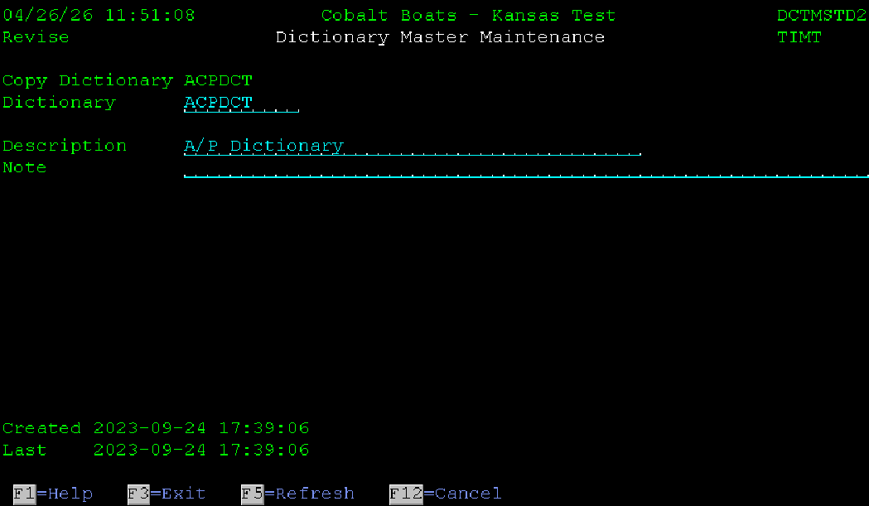

Screen Standards SFL Screens
SFL screens follow all the guidelines as regular screens and add the following rules.
- Every SFL screen should have a record called FOOTER that is overlaid by the SFL. The command keys should go in this record so they are at the bottom of the SFL.
- Each column of the SFL should have a position field at the top.
- The SFL should have a generic search field in the header.
- SFL options should be listed in blue above the column headers. The SFL options are populated via the APLSRVV1 services program. This handles F23 for more options. The field name should be OPTIONS. More information will be provided in the template system walk through.
- Column headers should be white and underlined. They should be justified in the same direction as the data under them. For example, numeric columns should be right justified and alpha columns should be left justified.
- There is no + or more option for the SFL, instead there is a message that shows the paging information. This provides more real estate for screen design. The message is generated as part of the template system.
The following is an example of a SFL screen.
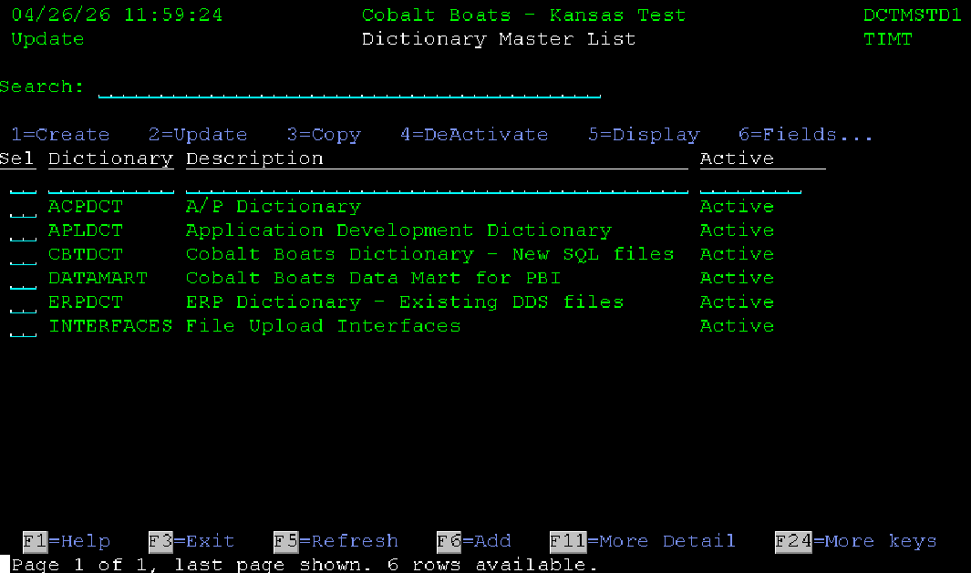

RPG Coding Standards
Review the programming standards overview section of this document for some base standards and the Capitalization section for capitalization standards.
The standards in this section are more RPG and template program specific.

Control Options (Ctl-Opt)
The following are the default control options. These should be in every program.
Option(*SrcStmt:*NoUnref) DftActGrp(*No) BndDir('CBT') Main(Main);
Each program should also designate the activation group. For a D1 list programs it should be ActGrp(*new). This is because they can be called redundantly. Most other programs should be ActGrp(*caller), only use *NEW if a redundant call needs to be handled.

Indenting
Most editors automatically handle indenting. All levels should be indented to improve code readability. The indention should be 2 spaces. The following is an example of some indented code. You can see how VS Code provides lines for the indentions to make it even easier.
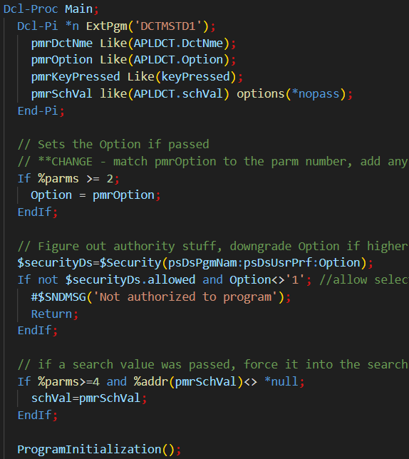

Loop Control
SQL cursors should use 2 fetch statements. This prevents a level of nesting and makes the code more readable. Some people are used to doing it a different way and there is nothing wrong with most other ways, but being consistent will help everyone out in the long run.
The following is an example of iterating through an SQL data set. In general, this should be avoided, but sometimes it is necessary, like when printing a report.
// loop through the entries and print/add each one
Exec SQL Prepare sqlStm from :sqlStm;
Exec SQL Declare sqlCrs Cursor For sqlStm;
Exec SQL Open sqlCrs;
Exec SQL Fetch Next From sqlCrs Into :dta;
DoW sqlState < '02';
AddDetailRecord();
Exec SQL Fetch Next From sqlCrs Into :dta;
EndDo;
Exec SQL Close sqlCrs;
Notice how there are just 2 fetch statements. Other options normally add a level of indention and get down to a signal fetch statement, but that adds unneeded complexity. If working on non-template program code, this same type of loop can be done with SetLL and Read operations.

DRY Principals
All development should follow DRY principles (Don't Repeat You). This is implemented by never duplicating the same piece of logic. In practice it generally means making a procedure that gets called from multiple places, instead of putting the same logic in multiple places.
If a piece of logic needs to be used in multiple places, consider making it a procedure in a service program or at least a called program so the logic does not have to be maintained in multiple locations.
A system should be designed so that one operation is only ever done in one program. For example, a program may be generated where an order is entered. Then there could be multiple places where the order needs to have its status changed. Instead of adding status change logic to multiple places throughout the system, a single program or procedure should be developed to make the change. That procedure can be called with whatever parameters are needed.
The reason this type of logic is preferred is to make code more maintainable. For example, what if someone wants to add the option to send a notice to a customer when an order status is changed. If that code was put in a lot of programs, every program would need to be identified and changed to send the notice. This creates problems where some changes may not be found and the customer may not get updates.
If someone later wants to change the type of statuses that are reported, then all the work would have to be done again to try to locate all programs sending the messages. This creates more room for error and requires more long-term work and synchronization problems.
Developing using DRY principles up front speeds development, reduces maintenance and prevents errors.

CL coding Standards
Since CL is not used as much in modern coding, there are not a lot of standards written for it. Just use most of the RPG standards, indent two spaces and so on.

Base function service program
The base function service program provides many standard functions to developers.
All functions start with #$ so they do not collide with other naming conventions.
To use the base functions, just include the copy book for the prototypes and ensure it is in the default binding directory used in the program. The following example shows how to use #$ENVNME. This procedure returns the name of the current environment.
First ensure that the control options have a binding directory that includes the BASFNCV1 service program. At Cobalt that is BNDDIR(‘CBT’).
Next include the copy book for the base function’s procedure.
Then you can use the base functions. It ends up looking like this:
0001.00 **FREE
0002.00 Ctl-Opt Option(*SrcStmt:*NoDebugIO) DftActGrp(*No) BndDir('CBT') main(Main);
0003.00
0004.00 // Example using base functions
0005.00
0006.00 /Copy QSRC,CBTFNCV1PR // prototypes for all #$ procedures
0007.00
0008.00 // Program entry procedure
0009.00 Dcl-Proc Main;
0010.00
0011.00 DSPLY #$EnvNme();
0012.00
0013.00 End-Proc;
Line 2 includes the binding directory that has the CBTBASV1 service program in it.
Line 6 includes the copy book with all the prototypes.
Line 11 just calls the #$EnvNme function and displays the returned value to the screen.
The base functions copy book also has the entire PSDS defined. This can cause problems when adding it to an existing program. If this is being done any other references to the PSDS have to be removed and pointed to the declaration in the base functions copy book.
There are also a bunch of constants defined for use with some of the functions. Directions for those functions will detail out what constants are used with them. That is outside the scope of this document.
See the BASFNCV1 Service Program, #$ Functions document for full details.

Template Program Service Program
The service program APLSRVV1 contains a bunch of procedures used by the template program system. This section documents what most of the procedures are and do. The section of this document about template programs has more information on their actual use.
To use the APLSRVV1 functions, the program must include a binding directory that includes the APLSRVV1 service program and the copy book must be included for the prototypes.
All application service program functions start with a $.
The following is the list of functions, constants, and fields included with the application service program.

Fields
The APLSRVV1PR copy book includes the following predefined fields
found indicator; // Generally used to see if a record exists, but can be used for anything
keyPressed char(10); // used to store the value of the key pressed when leaving a screen.
outCol and outRow zoned(3); // used on the screen for cursor positioning
APLDCT, a template data structure for all fields in the APLDCT dictionary, any other dictionaries will need to be referenced manually.
InfDs_prt a template data structure for the InfDs for print files
InfDs_db a template data structure for the InfDs for database files
InfDs_icf a template data structure for the InfDs for ICF files
dspDs a template data structure for the InfDs for display files
Indicators DS, this is used to overlay the following indicators to named variables
- 11 -> SFLdrop
- 50 -> SFLclr
- 51 -> SFLdsp
- 93 -> AlwF23
- 98 -> EOF
fncDs - a data structure used to store the function key data for the program
optDs - a data structure to hold all the SFL option parameters for the program.

Procedures
$ClearMessages - Clears the message SFL
$ErrorMessage - Handles error messages
Handles all error messages adds error to message SFL, turns on error indicator, Optionally positions cursor to and highlights a field
Example for error message only
$ErrorMessage('NVT0001');
Example for error with substitution text and error flag
$ErrorMessage('NVT0001':brand:error);
Example for message with field and substitution text
$ErrorMessage('NVT0001':brand1:error:brand1@:'brand1':outRow:outCol:psDsPgmNam);
Example for message with field, substitution text and an additional field to highlight
$ErrorMessage('NVT0001':brand1:error:brand1@:'brand1':outRow:outCol:psDsPgmNam:brand1@);
Up to 20 additional attribute fields can be passed.
$ReturnKey - Returns a text version of a pressed key, see the DisplayScreen procedure in the template programs.
$GetFieldLocation - Get the location of a field on the screen, used to position the cursor to a specific field. Often used in the InitializeProgram procedure in a template program.
$GetFunctionKeys - Get function key information for this program, returns an instance of the fncDs data structure. The DS will be passed as options to several other function key procedures. This is used in the InitializeProgram procedure of template programs.
$ValidKeyPressed - Tests if a keypress is valid for a program
$NextFunctionKeys - Get Next Function Key String, used to roll through function keys with F24.
$ChangeFunctionKey - Changes the text on a function key, for example if F11 is show inactive, once pressed this can be used to change F11 to hide inactive.
$ChangeFunctionKeyAttributes - Changes the attributes of a function key, can be used to highlight function keys and such.
$Security - returns security information. This is just a place holder for now.
$SetAttribute - Set the attributes of a field. It accepts a list of the attributes that should be set Options are:
ND - Non display
PR - Protect
RI = Reverse image
UL = Underline
BL = Blink, only on red
HI = High Intensity only on not red
CS = Column Separators, without HI turquoise, with HI yellow
Colors Options
Grn or Green
Wht or White
Red
Trq or CS
Ylw or Yellow
Pnk or Pink
Blu or Blue
Can be passed as a comma or space separated list.
$GetSFLOptions - Get SFL Options for this program, Returns instance of optDs
$NextSFLOption - Get Next SFL Options String, called when F23 is used
$ChangeSFLOption - Changes the text on a SFL option
$ChangeSFLOptionAttributes - Changes the attributes of a SFL option
$ValidSFLOption - Tests if a SFL option is valid
$ToggleSFLMode - Toggles SFL Mode between 1 and 0, handles SFL drop toggle
$ValidEnmDes - Validate an Enumerated Value Description
$ValidEnmVal - Validate an Enumerated Value Value
$BuildSearch - Builds search parameter comparisons for where clause in an SQL statement
$BuildSFLMessage - Builds message string for the bottom of a SFL screen

Template System
The template system is designed to be a starting point for every program. It wraps all other information in this document to a usable template program.
The main temple program is the DCTMST system. It is an example of a master maintenance program with update and search features.
While many programs do not need a full-blown master maintenance setup, this document is going to cover a walk through creating a new master file using the template system. This way all options will be covered. In practice any of the programs in this system may be copied to create smaller programs.
For this walk through a file will be created using the dictionary system. If installed the File Master System would be used to do this, but for now it will be done manually.

Caveats
There are a few caveats to the system set up at Cobalt Boats. They are being listed here so they are known before going through this tutorial.
The main issue is the library list. Since the LMI software was not quite configured correctly when the dictionary and program master system were promoted in, the library list must be changed while performing some parts of the development. The main change is adding the CBTBASPDN library before the COBALT library when compiling programs. This is because the dictionary files are in this library. It then must be removed before doing the help text.

Building the Database Table
The process starts first on a drawing board. Excel can work well for this, or a whiteboard or whatever is available and comfortable to use. Generally, an idea of what a file needs has already been proposed before coding begins, so this part may already be done.
List the columns needed in the table and their types. You can use plain English to start, but you will need to eventually create the segments in the dictionary system to handle all this. For this example, a basic country code file will be generated. This is a real-life example and is easily done since there are not many attributes.
First, we must come up with a file name and description. Since this is a country master file it will be called Country Master, following KISS principles.
Each word needs to have a segment setup in the dictionary segment maintenance. To get into the dictionary segment maintenance enter CALL DCTSEGD1 on a command line and press enter or use the shortcut command DCTSEG and press enter. The first screen shows the list of segments already set up in the system. The search field at the top can be used to see if a word has already been set up as a segment. Using the position to column for the Segment (Seg), it can be determined if a segment has already been set up.
Using the search, I can quickly see that there is already a segment set up for the word country and for the word master. They are COU and MST respectively. So, the file name will be COUMST.
Now a list of the columns needed in the file will be determined. A simple file like this just needs a country code and description. For example, purposes, it will also include an enumerated field for include in address. This field will have a value of Yes or No, (Y/N). This will provide a demonstration of using the system enumerated value procedures. Enumerated values are used to store a small value in the file but associate it with a longer human readable value for input and output programs. They provide autofill, validation and prompting automatically.
So the columns are:
- Country code
- Description
- Include in address
Each column needs a long and short name for the dictionary, and a type and size.
Using the dictionary segment maintenance each word can be looked up to see if there is already a segment for it. It has already been determined that the country is cou. Searching for code returns CDE. So, the short name for the country code columns is couCde.
For description the search returns DES, but we want a 6 character name to make everything flow easier. A good way to do this is to add a descriptor for description. In this case I would change the column name to country name instead of description. Name is segment NME, so the column becomes couNme.
The last column, include in address, has three words. This means that at least one of the segments needs to be a compound segment, including more than one word. First one can check if any of the words already exist in the segment file. A quick search turns up ADD for address. Nothing showed up for include. It would be best to use the segment already found and then create a compound segment for include in. Using the dictionary segment maintenance I positioned to ini, for include in and saw that nothing was using it, so it is an option. Then I thought maybe it should just be INC for include, since that would make more sense from a standard word point of view. So, I could use iniAdd, or incAdd. I randomly choose to use incAdd.
Finally, I need a length for each one as well. For the country code I will be using the 3 character ISO standards, so the size will be 3 characters. For the name I will be using a varchar(50) field, and for the include in address column I will be using an enumerated char(1) column, with values of Y=Yes and N=No. I will also add a default of Y to this column.
After this research I came up with the following columns:
- country_code for column couCde char(1)
- country_name for column couNme varchar(50)
- include_in_address for column incAdd char(1) Enumerate(Y=Yes,N=No)
Now each field needs to be added to the appropriate dictionary. This is done in the dictionary master maintenance. To get to the dictionary master maintenance use command CALL DCTMSTD1 or command DCTMST. The dictionary program lists the dictionaries set up in the system. For this example, I’m just going to add these columns to the application dictionary. Using option 6 in front of the application dictionary brings up a list of the fields in the dictionary.
One should check to ensure the field does not already exist in the dictionary before adding one. Searching for couCde, couNme and incAdd did not return any results, so each one will be added.
Option 1 is used to add a field. On the first screen, just enter the field name and type and press enter. The system will try to build the SQL name, column text and column headings from the dictionary file for you.
It looks like this:
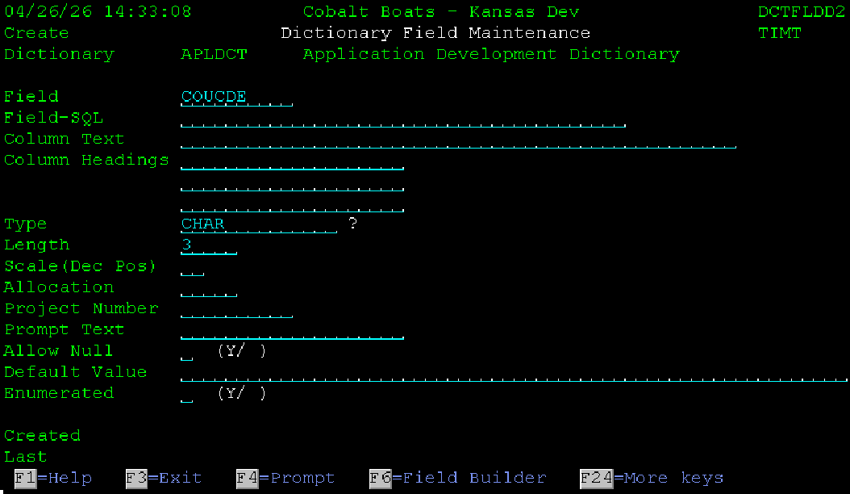
Press enter and it changed to this:
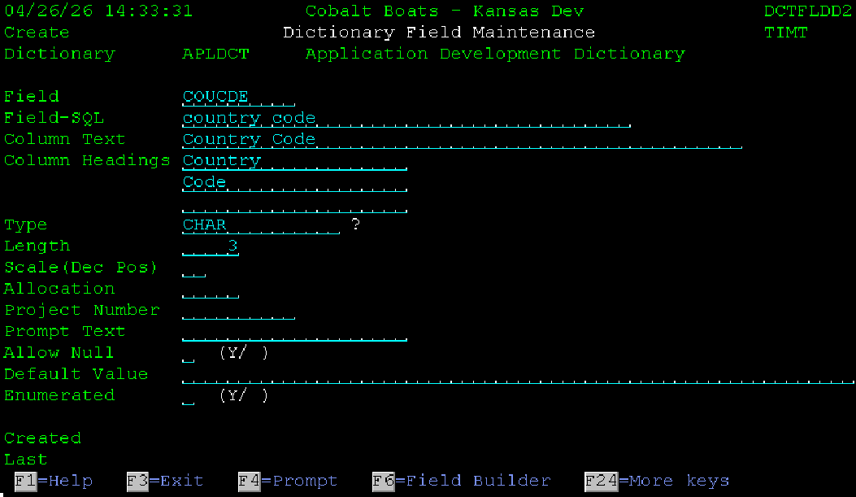
That is all that is needed for this field, so just press enter again to add it.
Repeat for country name, but since it is varchar, it also needs an allocation. I choose 25 for the allocation, as I believe it will be long enough to hold most country names.
When adding the incAdd field, I needed to manually change the SQL name, text and headings to include the word in since it was not in the dictionary values. I also had set the default and flag the column as enumerated. It ended up looking like this:
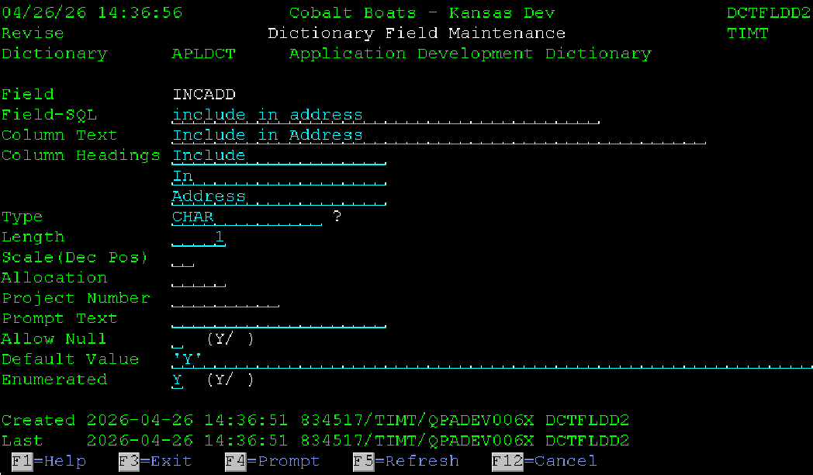
Once the enumerated field is set up the values need to be entered for it. This is done using option 9 in front of the column in the dictionary field list. Use option 1 to add a value. It should look like the following when done.
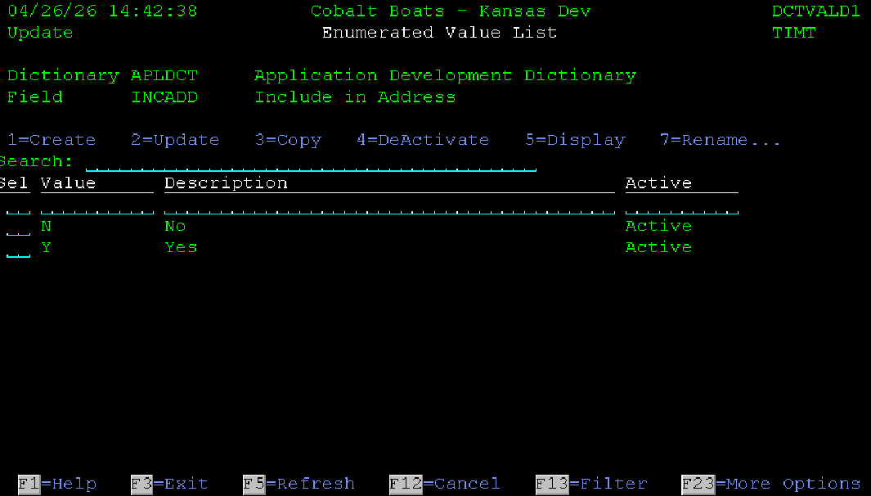

There is one more column that needs to be added to the dictionary. It is the identity column to the file. It is always the file name with idn appended to it. So, in this case it will couMstIdn. It is type bigint.
Now all the columns needed are in the dictionary. It is time to create the file. Since the file master system is not being used, this must be done manually. Also, there are 10 columns that get added to all new tables. They are the acvRow, identity column and the create and maintenance columns. So, this simple file will still end up having 13 columns when done.
To create a file, you just select the columns you need from the dictionary and use it in a generate table as SQL statement. It looks like this:
Create or Replace Table COUMST AS (
Select
acvRow,
idn as couMstIdn,
couCde,
couNme,
incAdd,
crtDtm,
crtUsr,
crtJob,
crtPgm,
mntDtm,
mntUsr,
mntJob,
mntPgm
From APLDCT)
Definition Only
Including Identity
Including Column Defaults
RcdFmt COUMSTR;
This would go in source member COUMST. You also need to declare the primary key and give the file a description. That is done via the next 2 statements. These go in the same source file.
Alter Table COUMST Add Constraint COUMST Primary Key(couCde);
Label on Table COUMST is 'Country Master File';
You can use the RS SEU shortcut to run the commands.
You can see from the column list the additional fields where added. The first column is acvRow. It is included in every table. The second column is the identity column for the table. It is generated from column IDN which is set up as an identity column. The column name should always be the file name with IDN appended to it. Even though we added couMstIdn to the dictionary, we need to generate the column using the idn field, so the identity works correctly. The last 8 columns are also always included, just copy them from a file that is already set up.
After this is done, a unique index needs to be set up on the identity column to ensure it is never duplicated. This is done by making a new source member named COUMSTIDN. It needs to contain the following text.
Drop Index If Exists COUMSTIDN;
Create Unique Index COUMSTIDN
on COUMST (couMstIdn);

Label on Index COUMSTIDN is 'Country Master File - by Id';

Library List Issues
There are some major issues with the library setup at Cobalt. To get all this to work correctly I had to put CBTBASPDN at the top of my library list. This is because the APLDCT file exists there in production and the ones in the data library are never updated. This should be cleaned up, but probably never will be

Creating Template Programs
This example is going to walk through creating temple maintenance programs for the country master file that was just set up.
This process uses the Program Master maintenance to populate all the appropriate files and copy the source members. Run the command GMMST to get into the program master maintenance. Position to the DCTMST to copy all the Dictionary Master programs to the new country Master programs. Use option 3 in front of all DCTMST programs and press enter. You can copy the source members via the program master if you desire. It is sometimes easier to just copy the entire group via PDM from CBTBASPDN to the new names in CBTBASDEV.
Once the source is copied, clean up the member descriptions. These should match the description added to the program master records.
At this point it is time to program. I like making a few mass changes first.
The program name and Key fields all need to be mass copied. Since the index column contains the program name, doing a mass replace on the program name also fixes this column. I do this in VS code because it can maintain the case correctly. Also, I prefer completing all the prototypes on the first run so I do not have to touch them again. Finally, there is no point in doing the mass replaces on the display files, help panels or _@ and _2 members. Display files will be touched manually as part of the process and the rest will get overlain. So I just open all prototypes files, the ones that end in PR, then open all the Dx and Bx members.
After updating all the prototypes with the proper names, I like to get some of the easy ones out of the way.
I generally start with the DZ and FZ members. Often on the DZ member you can delete everything but the active row selection and the sort option. Then remove any attribute columns that are not on a field. This would be the DES@ and DCTNME@. Change the title and compile the screen. You may get a message about the help columns, this will be fixed when using the SC option in front of the source member in PDM.
The SC command adds all the help text to the screen, builds the _@ and _2 members if needed, and creates the help panel group. It also updates the SCRLOC file which is used to determine where fields are on the screen. See the Display File Preprocessor section of this document for more information. Then you can compile the DSPF and everything should work.
The DZ filter program needs to have all the references to the removed fields cleaned up. This was the DCTNME and DES fields. There are only a couple references. Once removed the program should compile. You should also change the program description at the top to be correct. More items could be added to the filter, but I normally get the programs functioning first and then decide if I need to add more features. In a program like this more features are probably not needed.
Once compiled, I move on to the B0. It normally needs minimal changes to get running. First change the program description at the top. Then do the mass replacement on the program name. The dictionary master had a few extra special options. I just delete them from the special options section of the program. This is before the main program loop. They are Option 6 to view the dictionary fields and option 9 to rebuild the dictionary. I leave option 11 in there even though logging is not enabled since the file master system is not being used. At some point this might be implemented, so there is no issue with leaving the code in there for it. It also makes a good place holder to see where special options are added.
Since this master maintenance is only going to have one screen after the list, the rest of the program can be left as is.
Then I move on to the BP program. This is a prompt program that is used and the auto prompter for programs where the country code is used. Change the title at the top, and mass replace the company name. Then the fields it uses need to be changed. The dictionary prompter used the dictionary name and descriptions, fields dctNme and des. Those need to be changed to the country code and country name fields, couCde and couNme.
Now it is time to get to the real coding. All the boilerplate code is in place. It is time to start the D1 main lit program. This program takes a little more effort to get going. The first thing that needs to be done is the DSPF file needs to be updated. Many of the changes to the display file are going to mirror all the other DSPF changes. You will change the title at the top of the screen to the correct name. Then all the columns will be updated. In this case we are keeping a similar format and just changing the dictionary name to country code and the description to country name. We will also be adding the include in address field.
I normally start in SDA and change the title. This allows me to use the AC shortcut to center it. I then add the position to columns correctly. In this case I had to remove a line from the SFL so I could use two lines of columnheaders. I also removed the more information line as it is not needed for this file. This means that I have to change the number of lines per age for the SFL.
I then go into SEU to make a lot of the other changes. Since I foed in the position to line, I need to add the referencing back to it. I also need to ensure each variable ends with a 1 and that they all have the correct attribute field assigned to them. Once that is done I copy the fields up to the SFL, remove the 1’s and REFFLD keyword. Then I move them down one position and change the type to O. This makes everything line up exactly with the position to line.
Once finished the SFL line looks like this:
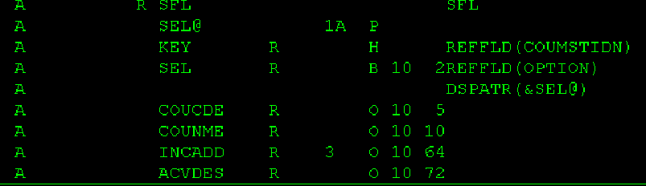
There are several things to pay attention to when doing D1 type list programs. The first is that every visible column in the SFL needs a position to column. The next is that you must have a key column. In this case the key is the identity column, it is a good idea to always use the identity column for the key, as that is what the template programs are set up for. The key column should be hidden. If it is in the visible subfile the column should exist twice, one named key and one with the appropriate column name.
If using the same column twice the alias for the column must manually be changed. For example, if the couCde column was used for the key and in the displayed SFL, then the alias country_name would be included in the SFL twice. This will not compile. The get around it just add an alias to one of the referenced fields. It looks like this in DDS: ALIAS(COUNTRY_CODE_KEY). That will make the long name for the column different from the other couCde column and allow the program to compile.
Finally in this example you will notice that the size of the incAdd field is overlain to 3 characters. This is because the column will show the enumerated value of Yes or No, not the field value of Y or N.
Next in the SFL header, there is a position to line. This line must have the same variable names as the SFL line, with a 1 appended to them. For this example, since the SFL has a couCde column, the position to column is couCde1, for the first line. This is used in the template program and to build the data structures that will be built in the _2 attribute member.
Once this all looks good, use the SC PDM option to add the help text and compile the screen with option 14.
After the screen is ready, it is time to build the SQL statement that will load it. It is very important that the SQL statement matches the columns exactly. This is because the search feature and position to columns are all automated. They use the field names from the screen in the SQL statement. If any of the column names do not match the field names, then the search and position to features will not work. Also, the order of the columns must match. However, the Sel column is ignored.
So, for this SQL statement, it needs to return columns key, couCde,couNme, incAdd and acvDes in that order. The statement should look like this:
Select
couMstIdn key,
couCde,
couNme,
coalesce(inc.enmDes,'') incAdd,
coalesce(acv.EnmDes,''Error'') AcvDes
From COUMST
Left Join DCTVAL as inc
on (inc.DctNme,inc.FldNme,inc.EnmVal) = ('ERPDCT','INCADD',incAdd)
Left Join DCTVAL as acv
on (acv.DctNme,acv.FldNme,acv.EnmVal) = ('APLDCT','ACVROW',COUMST.AcvRow)
Notice that the columns match exactly and that the enumerated values are pulled from the dictionary value file.
Now it is time to start writing the D1 program. We already have the boiler plate code copied from the template DCTMSTD1 program. Open the member in your favorite editor. First change the program description at the top. It should have read Dictionary Master List, change it to Country Master List.
Next, we are going to do some mass replacements to get a bunch of the code corrected quickly. Change the program, file and key field names. Since the program is named DCTMSTD1 and the file is DCTMST and DSPF is DCTMSTF1, you can change them all by replacing DCTMST with COUMST. If using VS code, be sure to have it set to preserve the case, this makes everything look nice and follows the proper programming standards. I’m not sure how to do that in RDI. Next you would mass replace the key field name. If using the identity column of the table, this would have already been done with the first mass replacement. If not, do it now. For example, if the couCde was used as the key instead of the identity column, replacing dctNme with couCde would update all the key field references.
Now we need to get the new SQL statement into the program to load the SFL. This is done in the appropriately named procedure, BuildSQLStatement. It contains a statement starts with sqlStm = 'Select * From (+', Leave that part the same and copy the new SQL statement after it. You will need to indent it twice (4 spaces), add a plus to the end of each line and double up and quotation marks. It should look like this when finished:
sqlStm='Select * From (+
Select +
couMstIdn key, +
couCde, +
couNme, +
coalesce(inc.enmDes,'''') incAdd, +
coalesce(acv.EnmDes,''Error'') AcvDes +
From COUMST +
Left Join DCTVAL as inc +
on (inv.DctNme,inc.FldNme,inv.EnmVal) = (''ERPDCT'',''INCADD'',incAdd) +
Left Join DCTVAL as acv +
on (acv.DctNme,acv.FldNme,acv.EnmVal) = +
(''APLDCT'',''ACVROW'',COUMST.AcvRow) +
)';
Notice that the entire query is included as a subquery. This is required because each field must be referenced by the alias name, not the original field name. This is because the position to and search fields use the field names from the SFL for the column names. So, they get appended to the end of the statement.
For example: If “Where acvDes = 'Active'” where appended to:
Select
couMstIdn key,
couCde,
couNme,
coalesce(inc.enmDes,'''') incAdd,
coalesce(acv.EnmDes,''Error'') AcvDes
From COUMST
Left Join DCTVAL as inc
on (inv.DctNme,inc.FldNme,inv.EnmVal) = (''ERPDCT'',''INCADD'',incAdd)
Left Join DCTVAL as acv
on (acv.DctNme,acv.FldNme,acv.EnmVal) =
(''APLDCT'',''ACVROW'',COUMST.AcvRow)
It would get an error, because acvDes is not a column in any of the input tables. It is only an output alias. By using the query as a sub query, the final table has all the aliases as the actual column names so this works:
Select * From (
Select +
couMstIdn key, +
couCde, +
couNme, +
coalesce(inc.enmDes,'''') incAdd, +
coalesce(acv.EnmDes,''Error'') AcvDes +
From COUMST +
Left Join DCTVAL as inc +
on (inv.DctNme,inc.FldNme,inv.EnmVal) = (''ERPDCT'',''INCADD'',incAdd) +
Left Join DCTVAL as acv +
on (acv.DctNme,acv.FldNme,acv.EnmVal) = +
(''APLDCT'',''ACVROW'',COUMST.AcvRow) +
)
Where acvDes = 'Active’
At this point it is often easiest to just compile the program and see what else is wrong.
In this example the first error was that dctNme was not found. I can assume that all references to dctNme need to be couCde. I mass replaced those and compiled again. I did notice that dctNme in the SQL statement was correct so I changed those back. I recompiled and saw that there were 2 filters that we removed from the filter screen, so they need to come out of the BuildSQLStatement procedure. They were the name contains and description contains sections.
I also saw the section about the SFLDrop, we got rid of the second column so all that logic can go away. After removing that from the DisplayScreen and Main procedures, the program compiled. It can be called from the command line now with CALL COUTMSTD1. However, there is nothing to display since the file is empty. The D2 program now needs to be completed so data can be added to file, and the programs can be fully tested
I start with the D2 screen, F2. It contained the dictionary name, description and note. It should contain the Country Code, Country Name and include in address field. I start in SDA and change the title to Country Master Detail and center it with AC. I then changed all the Dictionaries to Country. Then I changed the Note header to include in address. I had to shift the data column over a little to get it to fit, easy to do in SDA with the - - = shortcut. Finally, I renamed all the fields to the correct names. I did not worry about the sizes or types, because that will come in from the reference files. The screen looked like this when I was done in SDA.
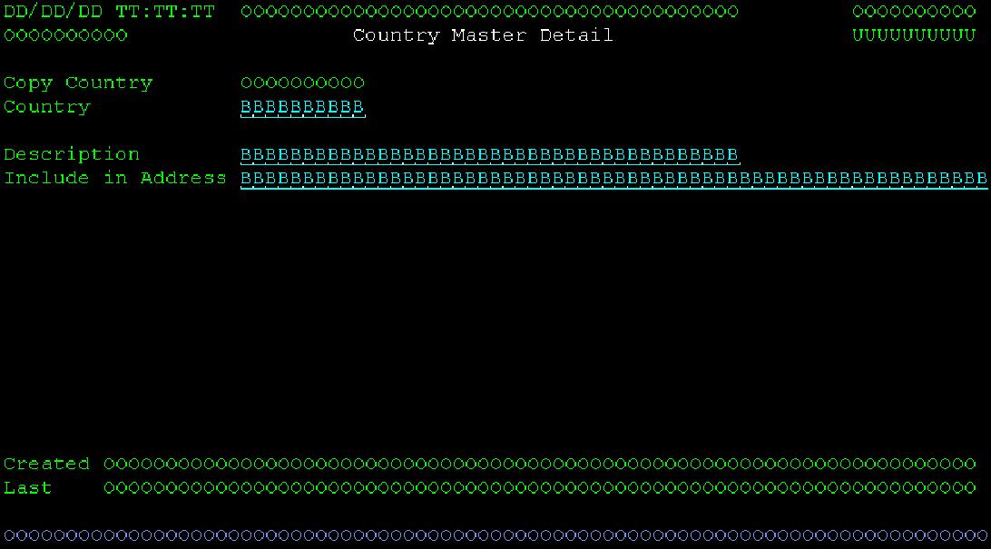
Now I open the member in SEU. If using RDI this can all be done in the editor by switching between viewing the code and GUI formats. I find it easier to just use SDA and SUE because I am familiar with them and the SDA shortcuts are fast. Of course, it can all be in the code as well using whatever editor you prefer, it’s all a matter of personal preferences.
In SEU I just delete all the help text stuff as it will be added back later with the SC command. I start from the top and just work my way through the code.
The first section that needs changed is the attribute fields. In this case it is the same field name changes I made in SDA. I changed DCTNME@, DES@ and NTE@ to COUCDE@, COUNME@ and INCADD@ respectively. If more fields were added, then additional ..@ attribute fields will need to be added as well. For template type programs, all user maintainable fields should have an attribute field the same name as the screen name with @ appended to it. These are referred to as the attributes fields. They are a program to file field and look like this in the SEU:
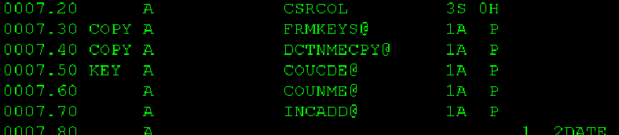
Notice that the 5-character gutter in the source file also has some special values. It is the words copy and key to the left of the A on some of the rows. There are 2 special values used by the SC command. The first is COPY, this is used to hide the previous value fields if not in copy mode. The second is KEY. It is used to input inhibit key fields when making changes. These are both added to special data structures in the _@ member generated with the SC command. In the RPG program you can see that the SetAttribute procedure changes the values of fldAtrDta, FldAtrKey and fldAtrCpy. These are defined in the _@ member and contain all the attribute fields on the screen. The COPY and KEY prefixes are what force those into different data structures. SDA removes these, so they always must be added back manually.
Next, I had to fix the REFFLD and DSPATR attributes on each field. Since I renamed the fields in SDA, the REFFLD now does not match the field name. Here is what it looked like before I changed anything:
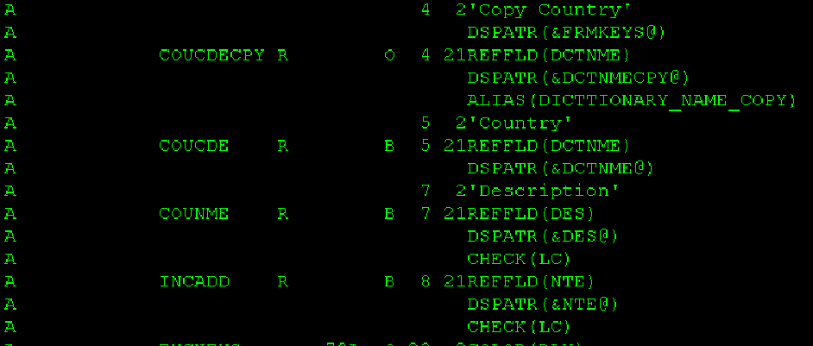
I had to change the REFFLD and DSPATR. For the REFFLD, I just removed them, except for the COUCDECOPY, which I changed to COUCDE. Since the DSPF has another field that references COUCDE, the copy version needs the alias renamed as well. After making the changes it looked like this:
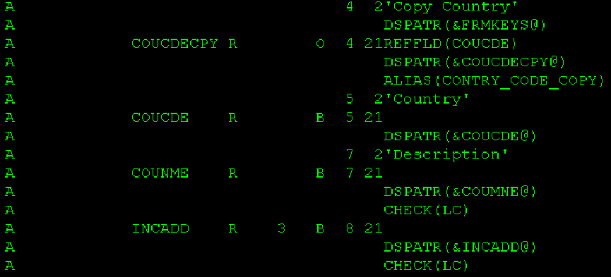
Notice that I also set the length of INCADD to 3, this is because it will contain the enumerated values instead of just a Y/N. It still uses the same field name so the automated help text will pick up from the dictionary field.
I also forgot to add the prompt marker for the enumerated field. All enumerated fields automatically have a prompt and validation program that will be discussed a little later. For now, it needs to be followed by a ? so the user knows they can prompt it. Also, the ? needs its own attribute field so it is not displayed unless the field is editable. It looks like this when done.
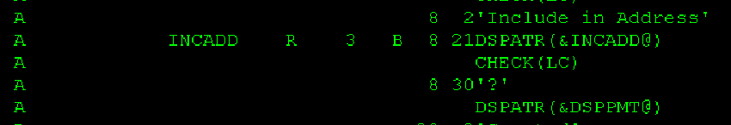
Once the screen is designed, use the PDM option SC to add the help text and build the _@ member.
Now it’s time to write the RPG program. The template is already there from the copying above. So, open the COUMSTD2 member in your favorite editor. Like all other programs, start by changing the description at the top. It says Dictionary Master because that is the program we copied. Change it to Country Code Detail. Then do the normal mass replace on the program name (DCTMST -> COUMST) and some others we know we will need from doing the other programs like dctNme -> couCde. In this example, we will be changing all references to des to couNme, and nte to incAdd. I did these manually because the short names appear a lot in the code. In RDi these can be done using a refactor since it looks at the type.
Any references to APLDCT for these fields also need to be changed to reference ERPDCT, since that is where they are defined. I generally just start at the top and work down the entire program, making all changes in one pass. I’ll cover the big ones as I go through them.
Starting towards the top, change the dta data structure. This is just used to read the values into and move them to the screen fields. It needs to match the SQL statement used in the InitializeProgram procedure. Since we know what fields we are using, this has already been done with the field renames mentioned above. One caveat here is that the incAdd field will be the description instead of the value. To make this easy the fields can just be defined like the regular fields name instead of referencing the dictionary. This works since the data structure is qualified and all the fields are defined on the screen.
Next the global variables for the parameters need to be changed if needed. This was done in the mass replacements above. If there is more than one key field, it will need to be added.
Starting in the Main procedure, the key fields may need to be updated. The command keys may need to be reviewed. Since this is a standard D2 program all the generic ones from the dictionary master program can remain the same.
In the DisplayScreen and SetAttribute procedures, there are generally no changes needed.
The ValidateScreen procedure always needs to be changed. It should validate anything needed on the screen. In this case there is an enumerated field. The system provides an autofill and validation program for enumerated fields and prompts. The details will be covered in their own section as to not clog up this walk through. Feel free to view that section now or just review how the code is entered in the example program.
In the UpdateScreen procedure, all updates need to be done. The template is already split out to perform tasks based on the program option. Just change the ones needed. The insert/copy and update sections generally need to be changed. If the table follows the standard of using the identity column for the key and including the acvRow column, the InActivate and ReActivate options should work from just the mass replacement done above.
The rename option is in there, but it should basically never be activated. This causes all kinds of problems if the key is used in other tables. However, if proper database design has been observed, all tables referencing this one should be using the identity and the code or key value can be changed safely. As a general rule I update the rename option to work correctly, but disable it unless I have thought it through.
The enumerated value fields has an issue here, we validated the description, but did not save the value. So, we need to pull the correct value to hold in the file. Some programs save this at validation time, but since this one used the same field name for the description, it needs to pull the value before an update or add is done. This is done easily by just querying the DCTVAL file for the value and saving it in a temp field to be used in the update and insert SQL statements.
The Prompt procedure must be updated with the prompt options. See the prompting section of this document for information on how to prompt an enumerated field.
The InitializeProgram procedure set up a lot of the base options in the program. Normally only the last section needs to be changed, where it pulls the information to display on the screen. If the dta data structure was updated already this is pretty easy, especially for a table with only a few fields on it, like this example. For larger tables like the customer master, it is often easier to design the screen, dta data structure and SQL statement to pull the data simultaneously.
TODO finish testing the program and update this document as needed.

Prompting and Auto Fill Fields
The system has two types of promptable and autofilled fields. The first is a custom written one. It exists for files where the user sets up the values in the file. The second is enumerated fields. These are for fields set up with values in the dictionary. The user cannot change these values.
Promptable fields should show the description, not the value. For example, a customer entry field should be the customer name, not number. The field should automatically do a search of the value entered and pull the correct number. The search should search customer number and the customer name and return both values if a single entry is found. If more than one entry is found, then the list should be displayed with the entered value in the search field, allowing the user to select the correct entry.

Promptable User Entered Fields
Each D1 master maintenance program should include a BP program to auto validate and fill in the correct value. The D1 program is the prompt program. The dictionary master program is a good place to copy the D1 and BP program from. However, there is not really a good example of it being used as a prompt program.
To use the D1 and BP programs, you must first copy in their prototypes at the top of the program. They should go after the template system copy books. It should look like this:
/Copy QSRC,CBTFNCV1PR // prototypes for all #$ functions
/Copy QSRC,APLSRVV1PR // prototypes for $ procedures used for template programs
/Copy QSRC,RPLBOMD1_@ // auto generated data structures for field attribute fields
/Copy QSRC,RPLBOMD1PR // Always include the prototype for the current program
/Copy QSRC,RPLBOMD2PR // Next program to call
/Copy QSRC,PRDMSTBPPR // Auto prompt part number
/Copy QSRC,PRDMSTD1PR // Part number search/maintenance
Notice there should be a comment after the copy books to inform developers of what the programs do. In this case the PRDMSTBP and PRDMSTD1 programs are used to prompt and auto fill a product/part number.

User Defined Autoprompt Program Example
The following is an example of a program using an auto prompt BP program. This code excerpt came from the ValidateScreen procedure of a template program.
First some parameter fields need to be defined. These will be defined in the ValidateScreen procedure so they have a local scope.
Dcl-S pmKeyPressed Like(keyPressed);
Dcl-S pmPrdNbr Like(CBTDCT.prdNbr);
Dcl-S pmPrdDes Like(CBTDCT.prdDes);

Something like the following code should exist in the body of the ValidateScreen procedure.
// make sure the to component is correct, Auto prompt first if not valid, handles ?
pmPrdNbr = cpnNew;
Clear pmPrdDes;
PRDMSTBP(pmPrdNbr:pmPrdDes:pmKeyPressed);
If cpnNew <> pmPrdNbr;
cpnNew = pmPrdNbr;
error=*on; // causes the screen to redisplay if a value is changed
EndIf;
found = *off;
Exec SQL select '1' into :found from MPMMP where pmPart = :cpnNew;
If not found;
$ErrorMessage('':'Invalid to component.'
:error:cpnNew@:'cpnNew':outRow:outCol:psDsPgmNam);
EndIf;
The first 7 lines after the comment handle the auto prompting. The next 6 lines just validate that the part number is valid.
In this example the part number is the field on the screen instead of the description. So, the first thing the program does is move the part number to the parameter field. This is done so the returned value can be compared to the passed value.
In this example the description is not used, so it is just cleared out. If the description were on the screen, it would be populated and part number would be cleared. When the description is on the screen, an input inhibited key field is normally included on the screen for display after the ?. This allows the user to see the part number they have selected. In this case both the key field (cpnNbr) and description (cpnDes) would need to be populated in the first if statement.
If the value is changed by the program, the screen is redisplayed, this is done by just setting on the error indicator. If the value matches exactly, there is no reason to redisplay the screen.

User Defined Prompt Program Example
Prompt programs are used in the Prompt Procedure of template programs. This is processed if the user presses the F4 key.
First parameters variables need to be defined inside the procedure. In this example they look like this:
Dcl-S pmPrdNbr Like(CBTDCT.prdNbr);
Dcl-S pmOption Like(APLDCT.option);
Dcl-S pmKeyPressed Like(keyPressed);
The pmKeyPressed is needed so that the returned key press does not process options in this program. The pmOption field is used to tell the prompt program to run in select mode. Then the key value needs to be defined to use if the user selects a value in the prompt program. Do not just use the screen field or it will be emptied if the user exits the prompt program without selecting something.
The code to call the prompt program looks like this:
ElseIf CsrFld = 'CPNNEW';
pmOption = '1';
Callp PRDMSTD1(pmPrdNbr:pmOption:pmKeyPressed);
If pmKeyPressed = 'ENTER';
cpnNew = pmPrdNbr;
EndIf;
Notice that the code block starts with an ElseIf statement. This is because the prompt procedure checks each promptable field on the screen, and in this example the field is not the first one. The prompt program is only called if the cursor is in the field being prompted.
If this is the field being prompted, the option is set to one to tell the calling program to run in select mode. When the program returns, if the user selected something, then they had to exit by pressing the enter key. The next if statement sets the selected value if so.

Promptable Enumerated Values
Enumerated values are easy to do because there is already a prompt program, auto fill and validate program and validation procedures set up for them. PGMMSTD2 is a good place to see an example of these in action. Search for the validation and prompts for aplDes (application description).
The prompt program is DCTVALDP, the auto promoter is DCTVALBP. Both programs require the dictionary and field name be passed, so they know what enumerated values to use.
The validation procedure for an enumerated description is $ValidEnmDes. For an enumerated value it is $ValidEnmVal.
To use the auto prompter and prompt programs, be sure to copy in the prototypes. The validation procedures are already declared in the APLSRVV1 prototypes and service program, so they should be included by default.

Display File Preprocessor
The Display file preprocessor is used to add all help parameters to an existing display file and to generate the help panel group for the display format. It also populates the SCRLOC file which contains a list of all fields on the screen. This list is used for generating the help text, in the help text maintenance programs and in the APLSRVV1 service program for positioning the cursor on the screen.
To use the Display File Preprocessor, use the PDM option SC in front a display file. This will remove any help fields in the file and add them back. It will create or replace the help panel group as well. For this to work correctly the program must first be set up in the Program Master file. See the Program Master Maintenance section of this document for more information. This is required because screen formats require the HLPTITLE keyword to include help text and the title is pulled from the description of the program in the help master file. Following the template program instructions will ensure that this step is done before getting to the screen design step.
Once the SC option is run for the display file the display will have these lines added:
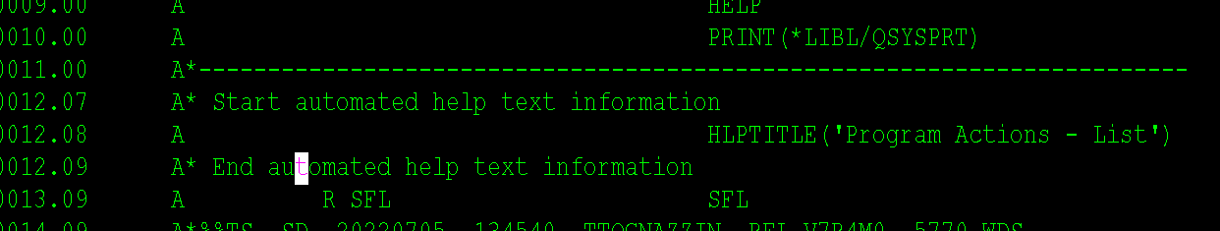
The HLPTITLE keyword will be added to the header section of the format. This will be before the first record format is added. All inserted lines are included between comments stating that the automated help text has started and finished.
Each record format in the program will have help text added for it. It looks like this:
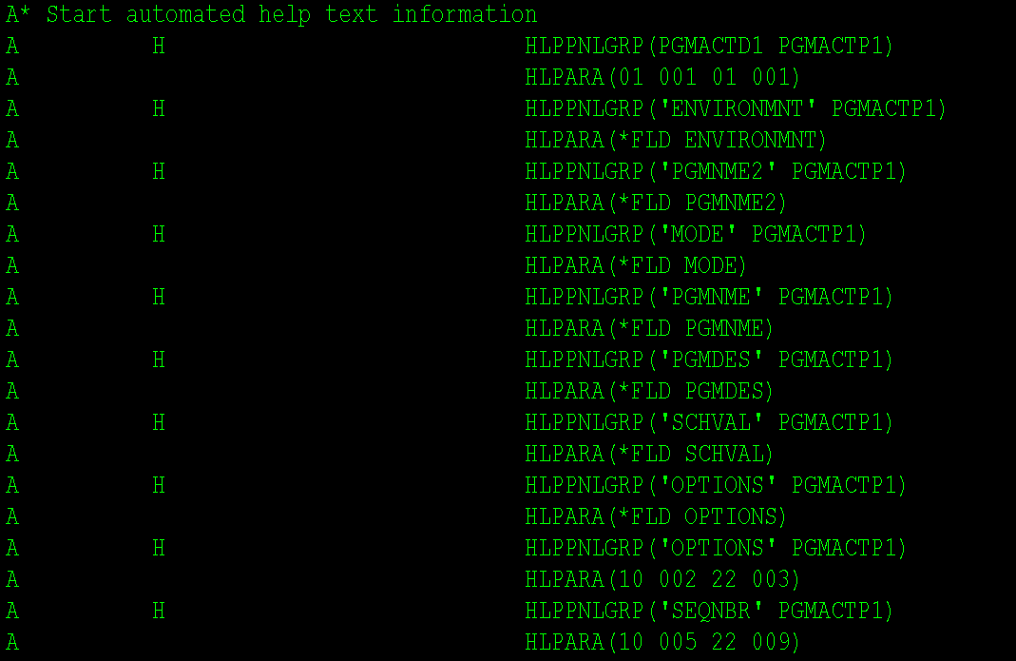
Notice that the header level fields are referenced by field name, but fields in a SFL are referenced by position. This allows the program to handle F1 being pressed on any line in the SFL.
Help fields are never added to the SFL itself, but they are added to the SFL footer record. There is also a single character help area added the screen header level help. See the Help Text section of this document for more information.

LMI Types and Codes
When setting up QSRC members in LMI use the following attributes. Make sure the source file is set to QSRC.
Source Type | Description | Obj Type | Obj Attr | Ext Attr |  | Obj Code | Scr Code
SQLRPGLE | Program | *PGM | SQLRPGLE |  | BND | 26 | 28
SQLRPGLE | Copy Book | *SRCMBR | SQLRPGLE |  |  |  | 26
RPGLE | RPG Program | *PGM | RPGLE |  | BND | 26 | 28
CLLE | CL Program | *PGM | CLLE |  | BND | 26 | 28
PF | Physical File | *FILE | PF |  |  | 1 | 2
DSPF | Screen | *FILE | DSPF |  |  | 26 | 28
PRTF | Print File | *FILE | PRTF |  |  | 26 | 28
PNLGRP | Help Text | *PNLGRP |  |  |  | 26 | 28
SQLTABLE | SQL Table | *TABLE | SQL |  |  | 1 | 2
SQLINDEX | SQL Index | *INDEX | SQL |  |  | 1 | 2
SQLVIEW | SQL View | *VIEW | SQL |  |  | 1 | 2

For SQL Tables, indexes and views, promote in with a source option of 2. When promoted to QUA they will exist in CBTBASQUA. Use CRTDUPOBJ to get them in either DATA_TEST or (DATA_KST and DATA_TNT). Ensure that there are never indexes, views or LF’s pointing to files/tables in another library. This messes up the replication software.
Copy books are of type SQLRPGLE, but they are the ones that end in PR, _@ and _2. These are not compiled, so make sure the Copy Book option is used above.

